**Problem statement:**

**In this case study, we are giving a real world example of how to use HIVE on top of the HADOOP for different exploratory data analysis. In here, we have a predefined dataset (yellow_tripdata_2015-01-06.csv) having more than 15 columns.**

**Queries for Hive Case study**

**Tasks:**

**1.Create a table named taxidata . Required ddl script is given below.**

Create database challenge;

Use challenge;

CREATE TABLE IF NOT EXISTS taxidata(vendor_id string, pickup_datetime string,dropoff_datetime string, passenger_count int,

trip_distance Float,pickup_longitude Float, pickup_latitude Float, rate_code int,store_and_fwd_flag string, dropoff_longitude Float,

dropoff_latitude Float,payment_type string, fare_amount Float, extra Float,mta_tax Float, tip_amount Float, tolls_amount Float,

total_amount Float, trip_time_in_secs int )ROW FORMAT DELIMITED FIELDS TERMINATED BY ','

TBLPROPERTIES ("skip.header.line.count"="1");

**2.Load data from the csv file - yellow_tripdata_2015-01-06.csv**

load data local inpath"/home/cloudera/sidd/Challenge/Mini project 3/yellow_tripdata.csv" into TABLE taxidata;

**Perform taxi trip analysis by solving the questions below:**

1. **What is the total number of trips ( equal to the number of rows)?**

**Hive> select count(*) as number_of_trips from taxidata;**

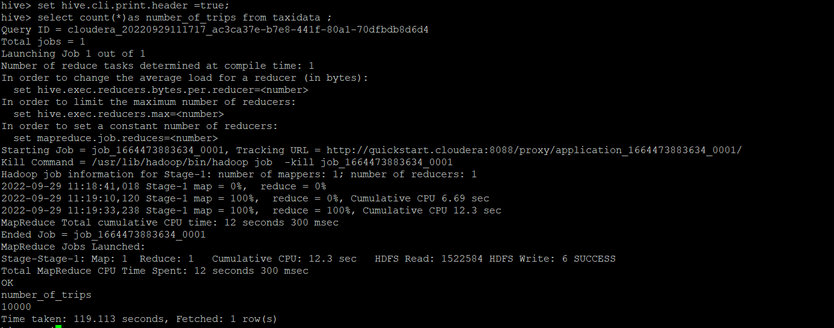

1. **What is the total revenue generated by all the trips? The fare is stored in the column total_amount.**

**Hive> select round(sum(total_amount),2) as total_revenue from taxidata;**

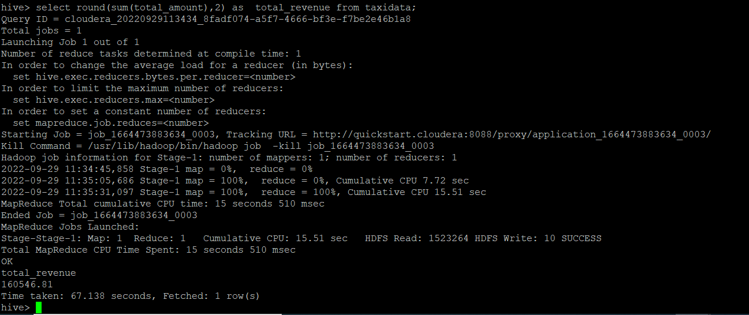

1. **What fraction of the total is paid for tolls? The toll is stored in tolls_amount.**

**Hive> select round((sum(tolls_amount)/sum(total_amount)),2) as fraction from taxidata;**

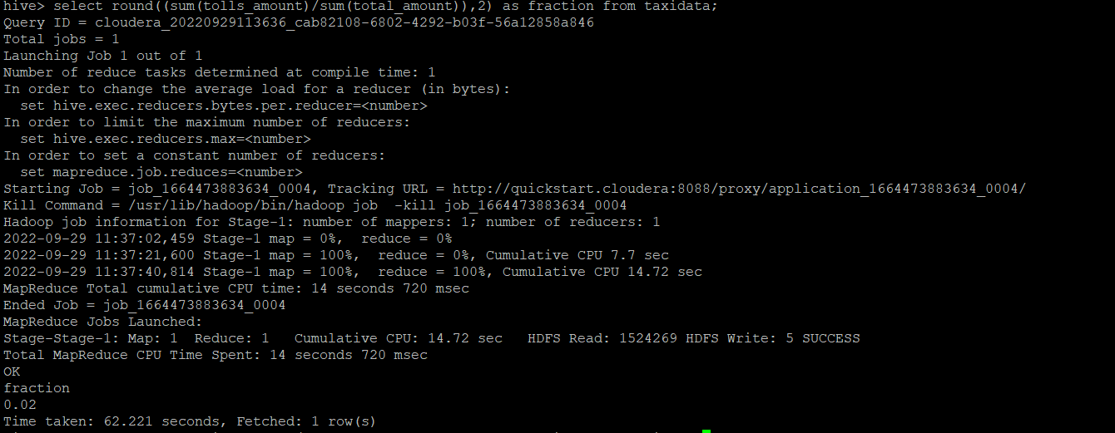

1. **What fraction of it is driver tips? The tip is stored in tip_amount.**

**Hive> select round((sum(tip_amount)/sum(total_amount)),2) as fraction from taxidata;**

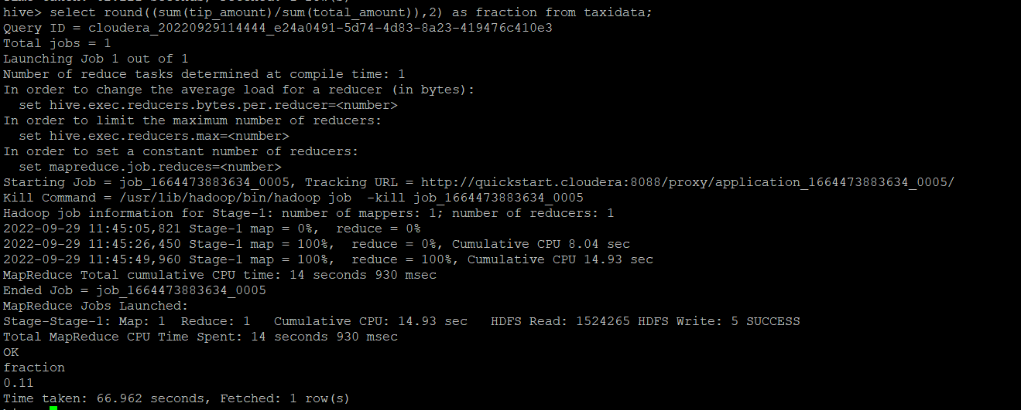

1. **What is the average trip amount?**

**Hive> select round(avg(tip_amount),2) as average_trip_amount from taxidata;**

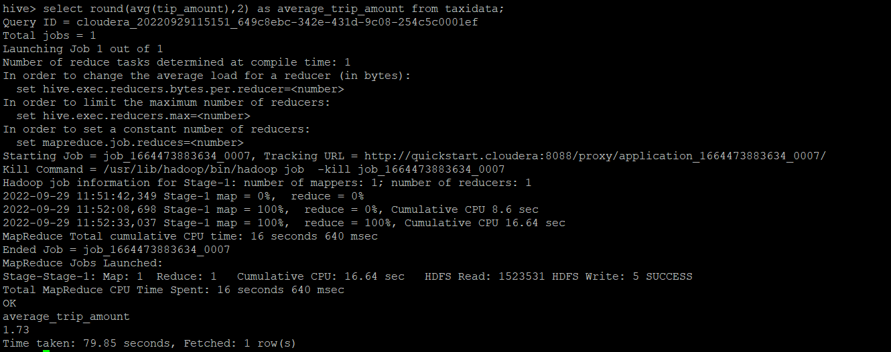

1. **What is the average distance of the trips? Distance is stored in the column trip_distance.**

**Hive> select round(avg(trip_distance),2) average_distance from taxidata;**

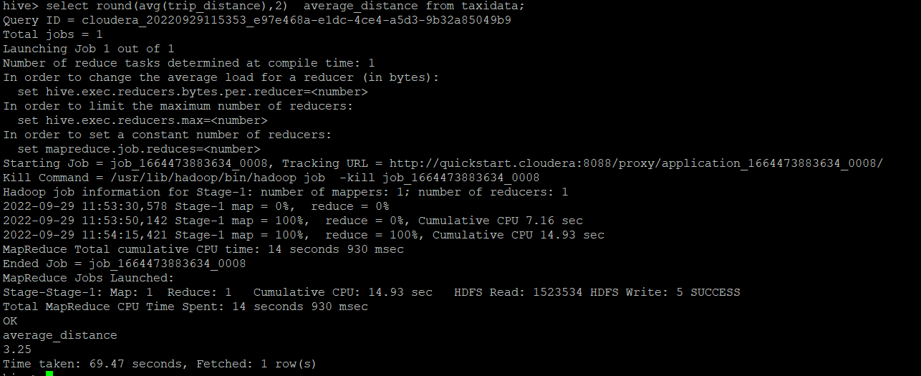

1. **How many different payment types are used?**

**Hive> select distinct(payment_type) as payment_types from taxidata;**

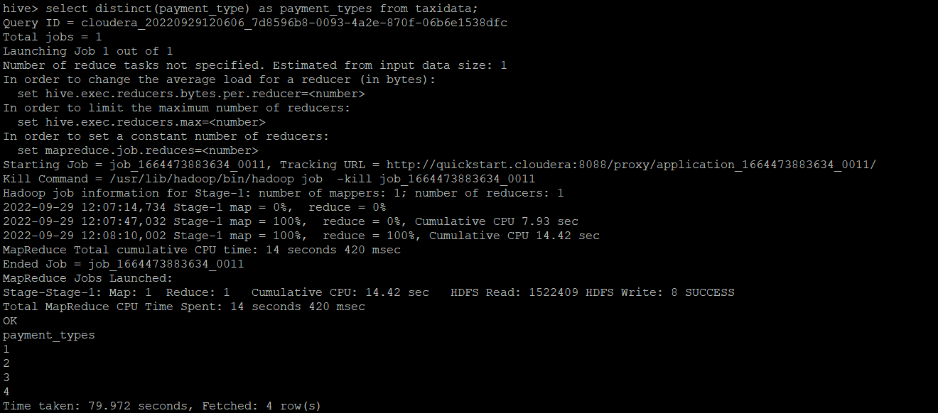

1. **For each payment type, display the following details:**

* **Average fare generated**
* **Average tip**
* **Average tax – tax is stored in column mta_tax**

**Hive> select payment_type, round(avg(fare_amount),2) as average_fare, round(avg(tip_amount),2) as average_tip, round(avg(mta_tax),2) as average_tax from taxidata group by payment_type;**

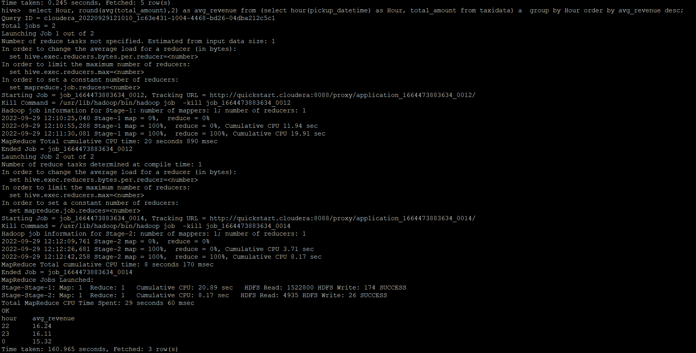

1. **On average which hour of the day generates the highest revenue?**

**Hive> select Hour, round(avg(total_amount),2) as avg_revenue from (select hour(pickup_datetime) as Hour, total_amount from taxidata) a group by Hour order by avg_revenue desc;**

